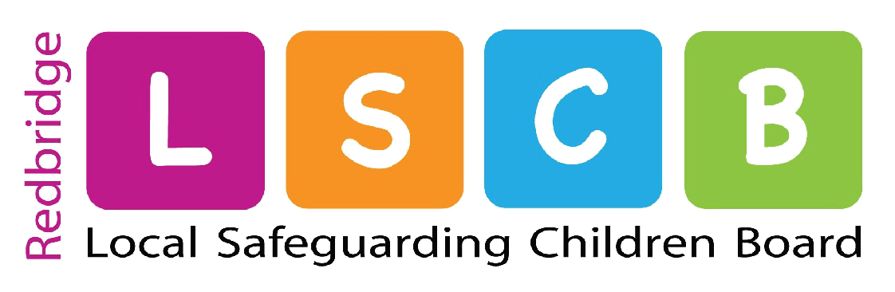

**Culturagram**

**Oppression and discrimination, bias and racism.**

**Contact with cultural and religious institutions, holidays, food and clothing.**

**Time in Community**

**Legal Status**

**Language spoken at home and in community**

**Values about family structure, power, myths and rules**

**Family-**

List individual members

**Impact of trauma and crisis events**

**Health beliefs**

**Values about education and work**

**Reason for relocating**