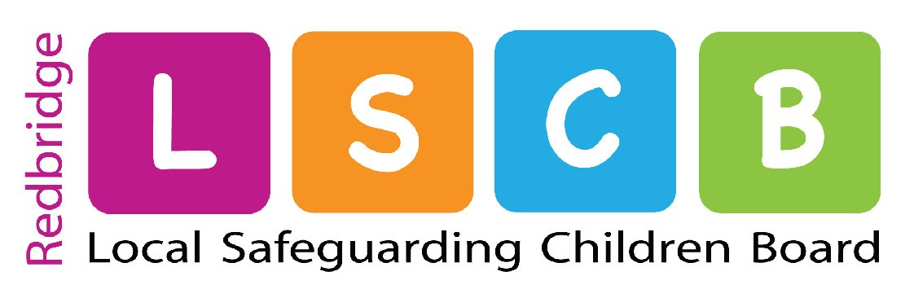
Independent Chair: John Goldup

LSCB Child Protection Conference Complaint Form
(for completion in relation to complaints made as part of the LSCB Child Protection Conference Complaint Procedure)

This is a complaint about (please indicate what the complaint relates to by marking the relevant point(s) with an X):

- the decision for the child to become, to continue or not to become subject to a Child Protection Plan;
- the category(ies) of abuse, determined by the Conference Chair, under which the child has been subject to;
- other decisions or recommendations made by the Conference;
- whether the London Child Protection Procedures about Child Protection Conferences, and other protocols were followed;
- the exclusion of any person from the Conference.

Only the following people can complain using this procedure. Please tick the description which applies to you:

□ the child who is the subject of the Child Protection Conference, where she/he is of sufficient age and understanding;

□ a person who is acting on behalf of and at the written request of the child, where the child is of sufficient age or understanding;

□ any parent and/or any person with parental responsibility for the child who is the subject of the Child Protection Conference;

□ where the child is subject to a care order or is otherwise looked after by the London Borough of Redbridge, a person who has the care of the child at the time of the conference e.g. a foster carer or the child’s key worker in a residential placement;

□ where the child has a disability, a person who attended the conference to act as an advocate for or otherwise assist the child;

□ the child’s solicitor.

Name of child(ren) subject of conference:
1 |  | 2 |  | 3
4 |  | 5 |  | 6

Date of Conference | / /
Venue of Conference
Chair of Conference (if known)
Your Name
Your Address
Telephone No.
Your relationship to the child(ren) concerned

Please state the background and reason for your complaint in the box below (please continue on the reverse of this sheet if required):
Signature |  | Date | / /

Please send the completed form to:

LSCB Business Manager
Redbridge Local Safeguarding Children Board (LSCB)
London Borough of Redbridge
4th Floor (Front)
Lynton House
255-259 High Road
ILFORD
Essex IG1 1NN or via e-mail to lscb@redbridge.gov.uk

