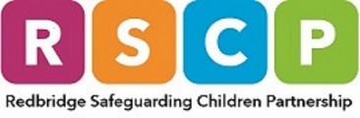
Child Neglect Toolkit Checklist

Child’s Name: |  | Date of Birth: | / /
Name and role of professional completing the checklist: |  | Team/Service/Agency:
Date of Completion: |  | Is there a Common Assessment Framework (CAF) or statutory assessment for the child/young person? | YES/NO

Development Need* | Score |  |  |  | Examples/evidence of impact on the child/young person
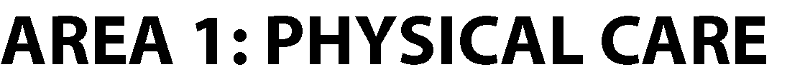 | 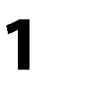 | 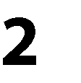 | 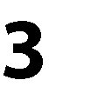 | 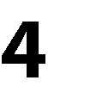
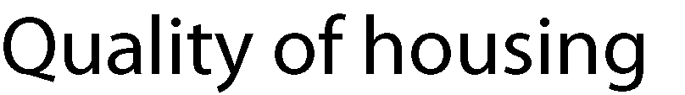
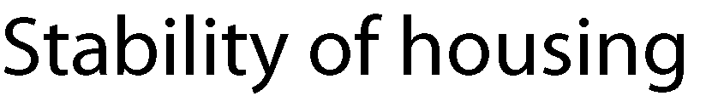
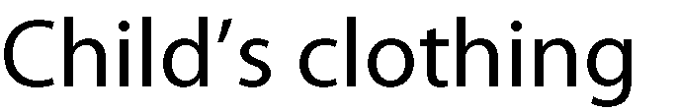
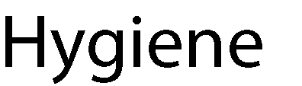
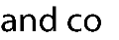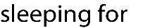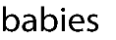
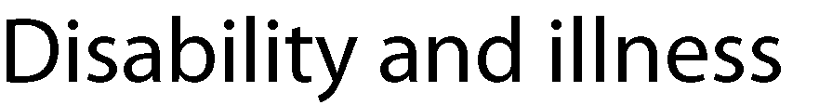
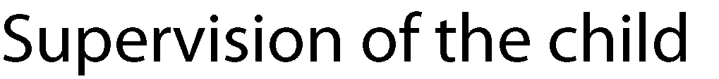
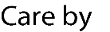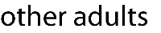
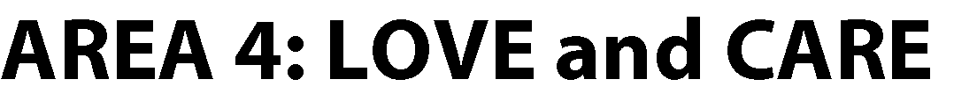
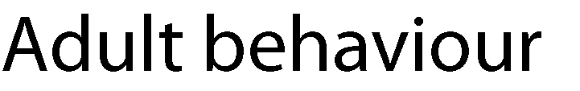
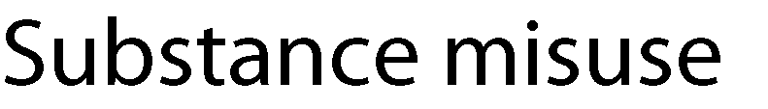

Development Need | Score |  |  |  | Examples/evidence of impact on the child/young person
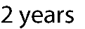
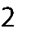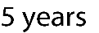

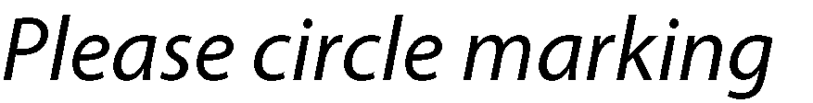

*A development need can be left blank if it has not been possible to gain insight into that area e.g., ‘not seen’ or ‘not applicable’, or ‘not known’.

Voice of the Child
Please include here any comments made by the child/young person which may provide evidence of impact of any neglect.

What actions are being taken following completion of this checklist?
e.g., raise at safeguarding supervision; refer to the Families Together Hub (FTH); complete a Multi-Agency Referral Form (MARF); etc.

