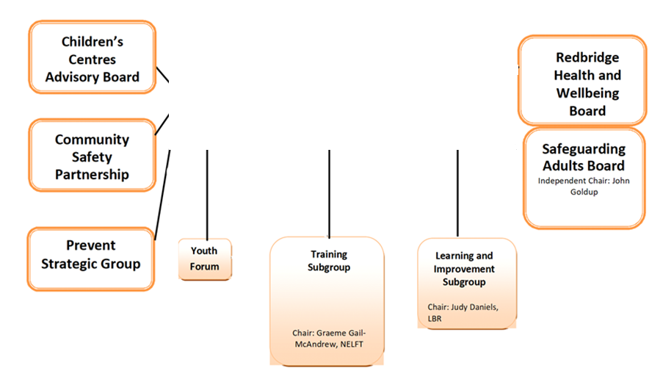

Board Manager: Lesley Perry

**Redbridge Safeguarding Children Partnership**

Independent Chair: John Goldup

Partnership Manager: Lesley Perry

**Barking & Dagenham, Havering & Redbridge (BHR)   
Safeguarding Partnership**